14. Write a program for congestion control using Leaky bucket algorithm.

Code:

#include <stdio.h>

#include <stdlib.h> // Include this for the rand() function

int main()

{

int buckets, outlets, k = 1, num, remaining;

printf("Enter Bucket size and outstream size\n"); scanf("%d %d", &buckets, &outlets); remaining = buckets;

while (k)

{

num = rand() % 1000; // Generate a random number between 0 and 999 if (num < remaining)

{

remaining = remaining - num; printf("Packet of %d bytes accepted\n", num); // Added missing variable

}

else

{

printf("Packet of %d bytes is discarded\n", num);

}

if (buckets - remaining > outlets)

{

remaining += outlets; // Fixed the calculation

}

else

remaining = buckets;

printf("Remaining bytes: %d \n", remaining); printf("If you want to stop input, press 0, otherwise, press 1\n"); scanf("%d", &k);

}

while (remaining < buckets) // Fixed the condition

{

if (buckets - remaining > outlets)

{

remaining += outlets; // Fixed the calculation

}

else

remaining = buckets;

printf("Remaining bytes: %d \n", remaining);

}

return 0; // Added a return statement to indicate successful completion

}

Output:

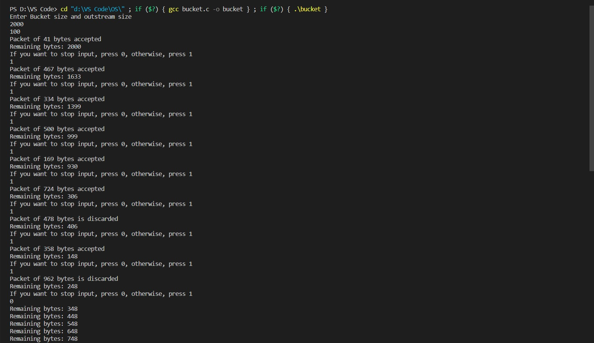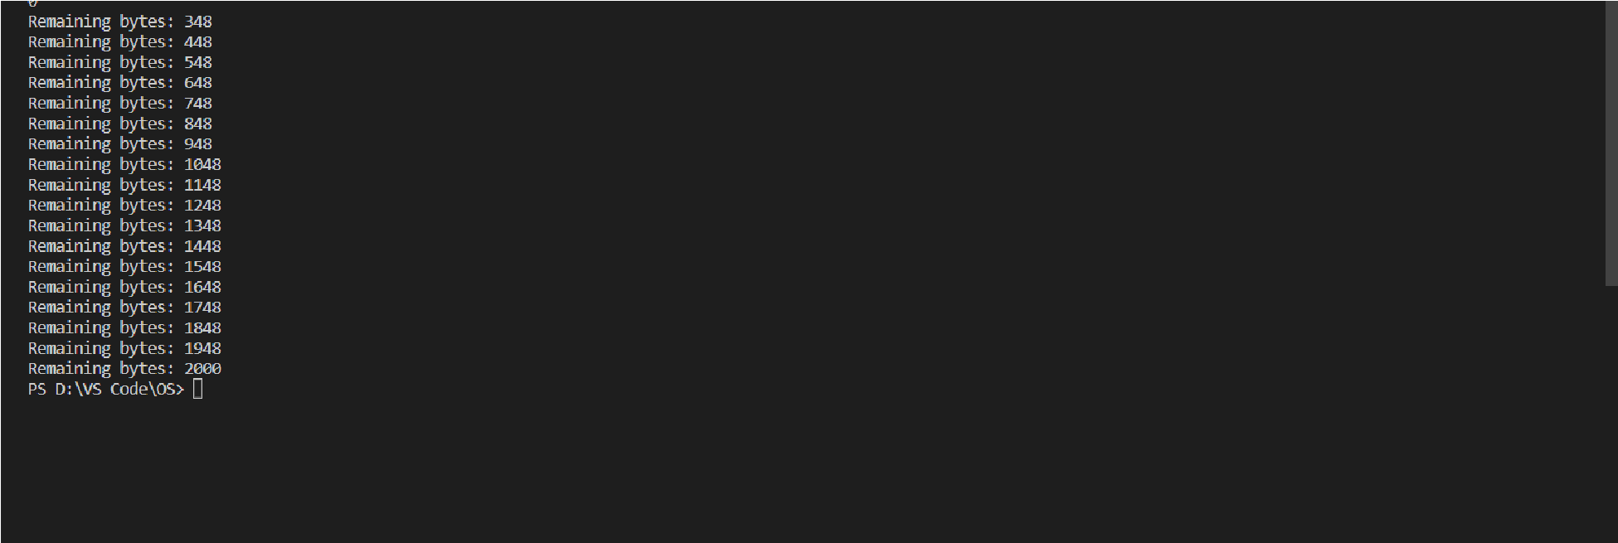

Observation:

